

Politecnico di Milano

A.A. 2015-2016

Software Engineering 2 Project

**myTaxiService**

**Code Inspection Document**

**Ver. 1**

**January 2, 2016**

Alessio Martorana - 860584

1 Classes/methods assigned to the group 3

2 Functional Role 3

2.1 Method general flow diagram 5

3 List of issues 7

3.1 Naming Convention 7

3.2 Indention 7

3.3 Braces 7

3.4 File organization 7

3.5 Java Source Files 7

3.6 Initialization and Declarations 8

4 Other problems 8

5 Appendix 8

# 1 Classes/methods assigned to the group

Here the method assigned to the group is stated:

* **readNode( org . w3c . dom . Node node )**

Location: **appserver/common/stats77/src/main/java/com/sun/enterprise/admin/monitor/stats/lb/InstanceStats.java**

# 2 Functional Role

The major functions of the method are there briefly described:

* read the XML node passed as a parameter
* if node has attributes, store some node’s attributes in private class variables if the attributes are not null
* get the nodes which are child of the node passed as a parameter
* For every node which is child of the node passed as a parameter:
  + If a local name is assigned for the node, store the local name in “childNodeName” variable, else store the node name in such variable
  + If the first child node of the node isn’t null, store its value in the “childNodeValue” variable
  + If the name stored in “childNodeName” variable is equal to “application-stats”:
    - If the first child node of the node is null, set the “aApplicationStats” to “true” boolean value, else set “aApplicationStats” to the boolean value given by java.lang.Boolean.valueOf(childNodeValue).booleanValue() call
    - If node has attributes, get node’s attributes and store some of them in private class variables if the attributes are not null
    - If “aApplicationStats” variable is set to true, add “true” boolean variable to the private class List attribute “_ApplicationStats”, if “aApplicationStats” variable is set to false, add “false” boolean variable to the private class List attribute “_ApplicationStats”

The following flow diagram better shows method functional role:

## 2.1 Method general flow diagram

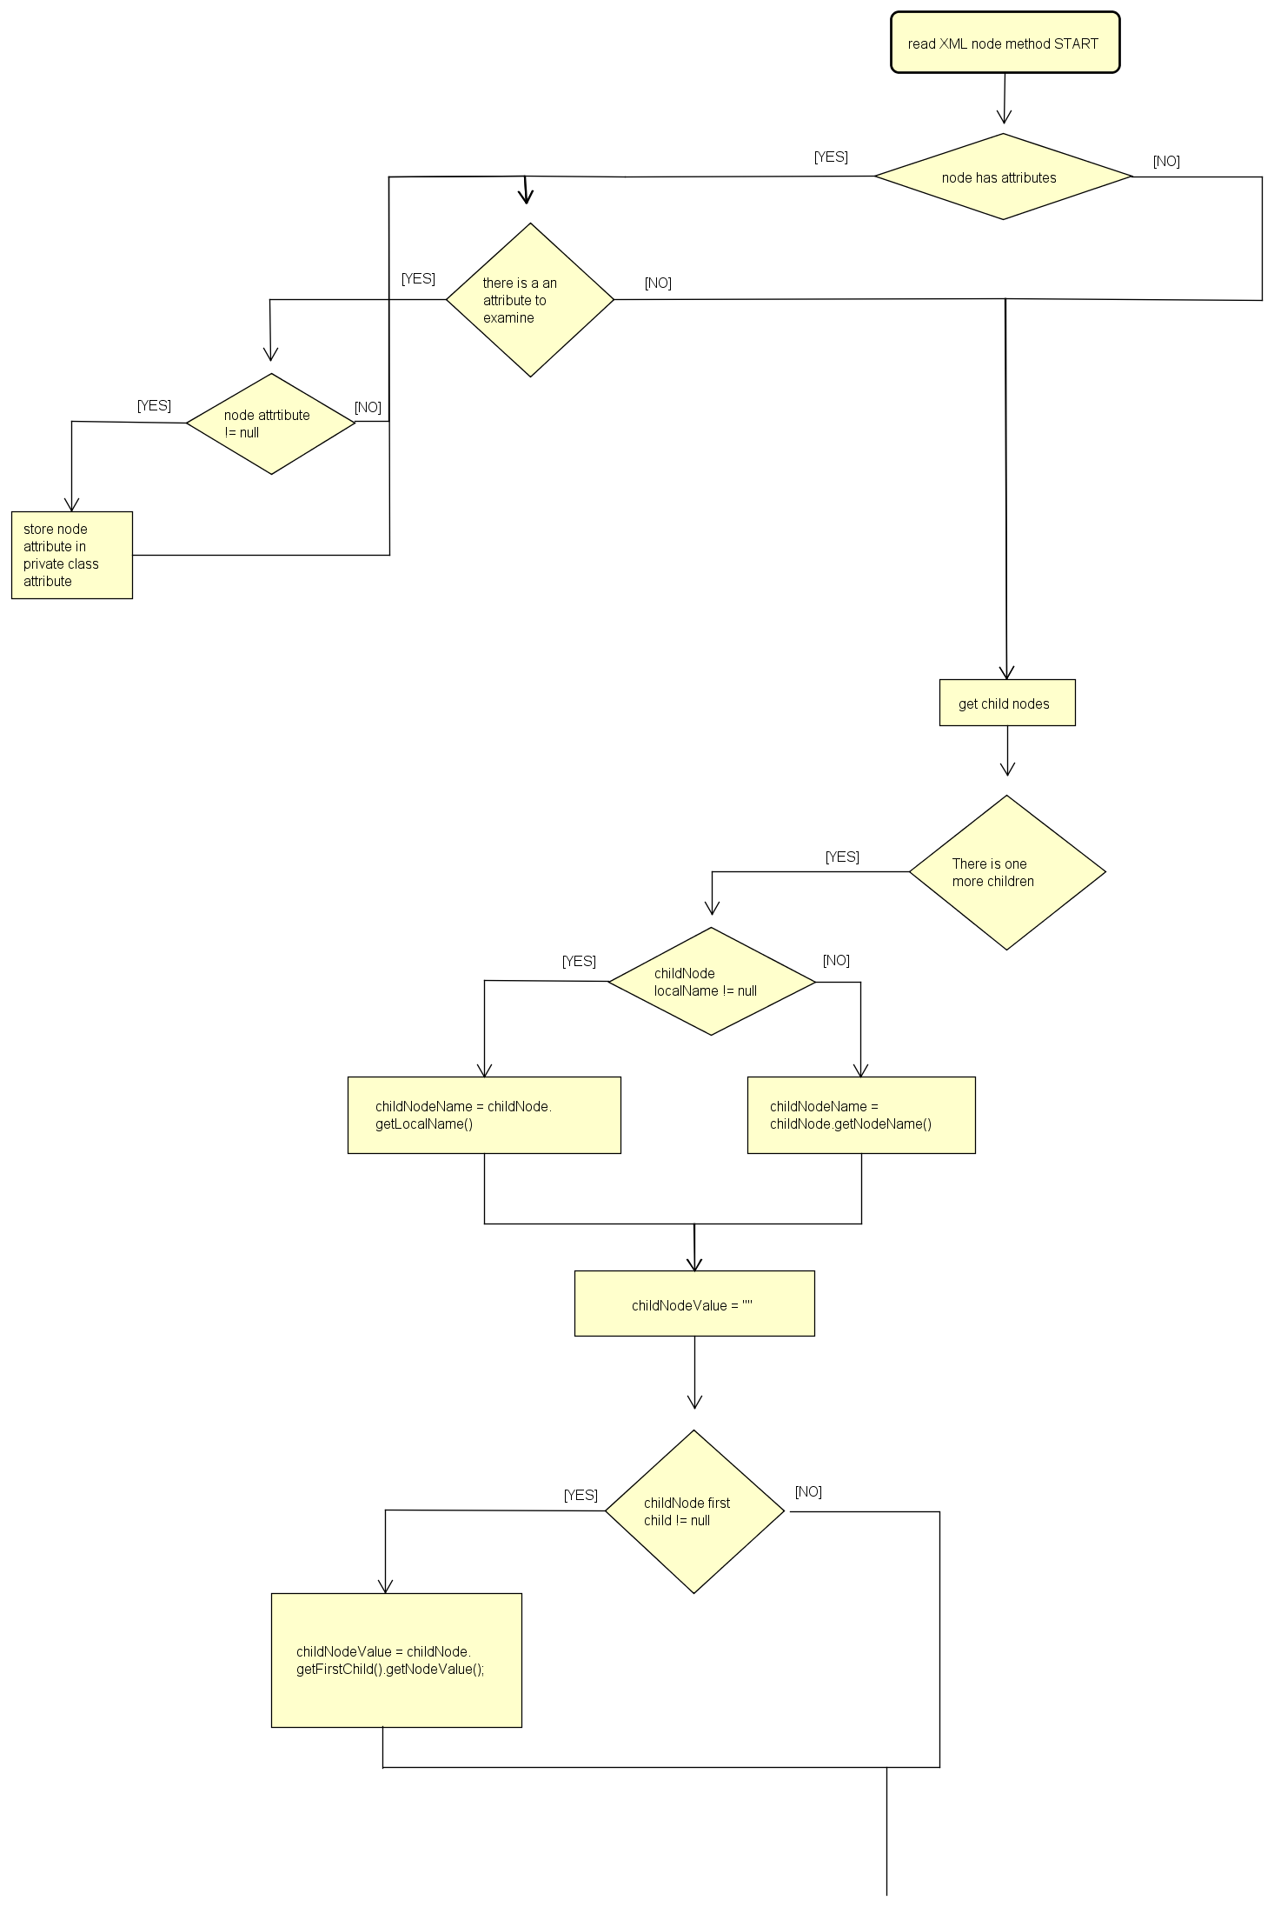

***pt 2***

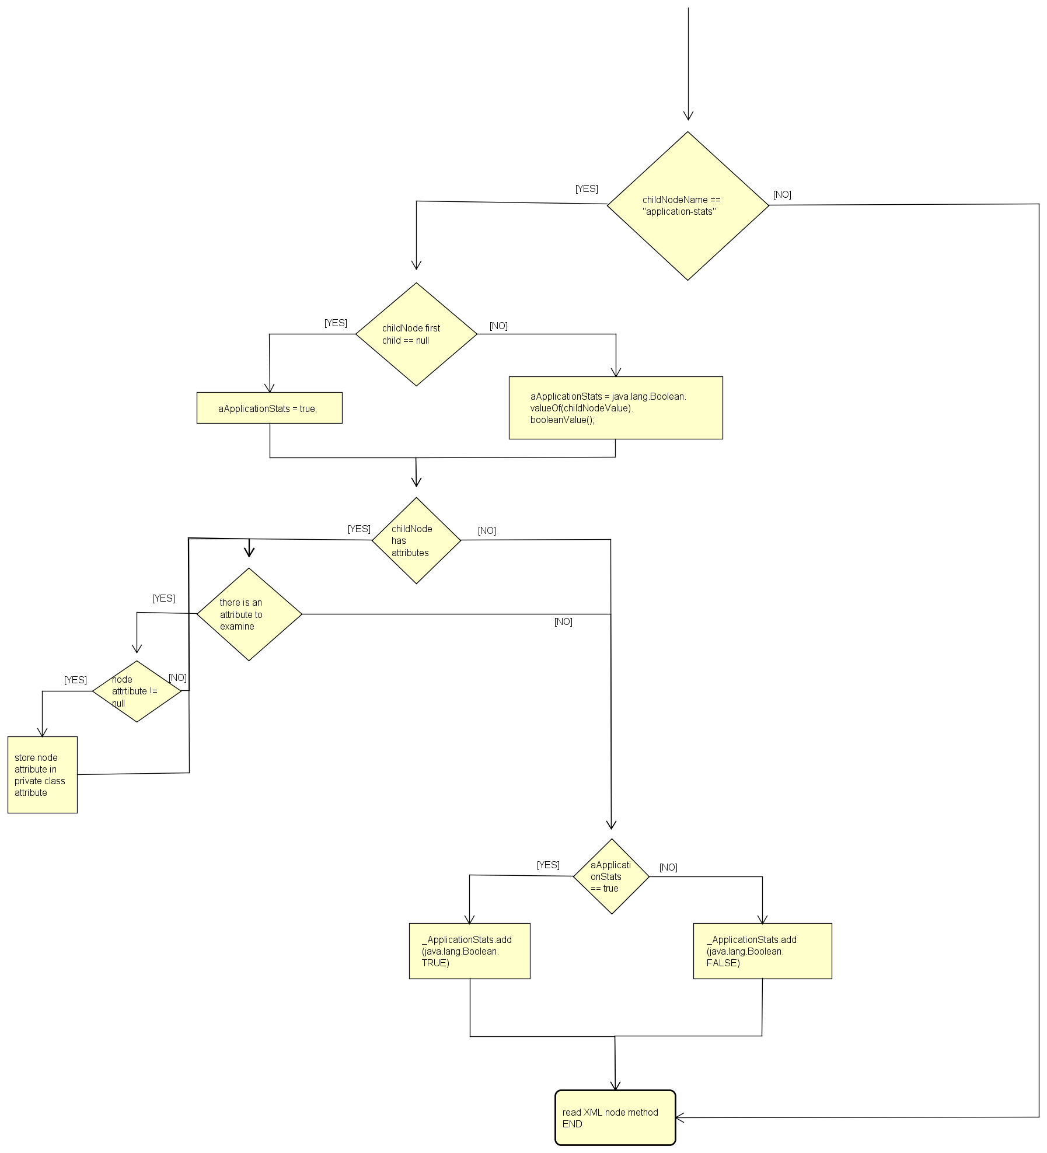

# 3 List of issues

## 3.1 Naming Convention

* Class variables at which the method refers (and all class variable in general) starts with an underscore, but the first letter after the underscore is not capitalized

## 3.2 Indention

* Four spaces are not used to indent, instead tabs are used

## 3.3 Braces

* At line 411 there’s an if with only one statement (one for the then branch and one for the else branch), but it is not surrounded by curly braces

## 3.4 File organization

* Line 404 exceed 120 characters

## 3.5 Java Source Files

* The Javadoc doesn’t provide any explanation on what the method does and on the meaning of the elements which the method uses and/or updates, the feeling is that the Javadoc is auto-generated, without a good human participation and revision

## 3.6 Initialization and Declarations

* At line 382 a variable is declared but it is not initialized at the same line, is instead initialized at the very next line: 383
* At line 400 declaration of “children” variable doesn’t appear at the beginning of the block of his scope
* At line 401 declaration of “lastElementType” variable doesn’t appear at the beginning of any block

# 4 Other problems

No other problems has been founded

# 5 Appendix

For the creation of this document I spent 30 hours.